**WEEK 2 – Advanced SQL Exercises for Online Retail Store**

4. SQL Exercise - Stored procedure

**Exercise 1: Create a Stored Procedure**

**Goal:**

Create a stored procedure to retrieve employee details by department

**STEPS:**

Step 1: Create Departments Table

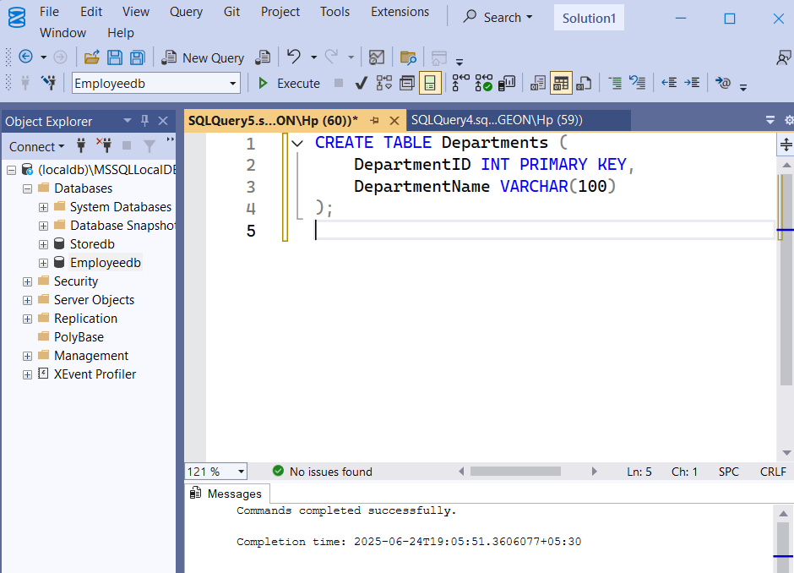

**Step 2: Create Employees Table**

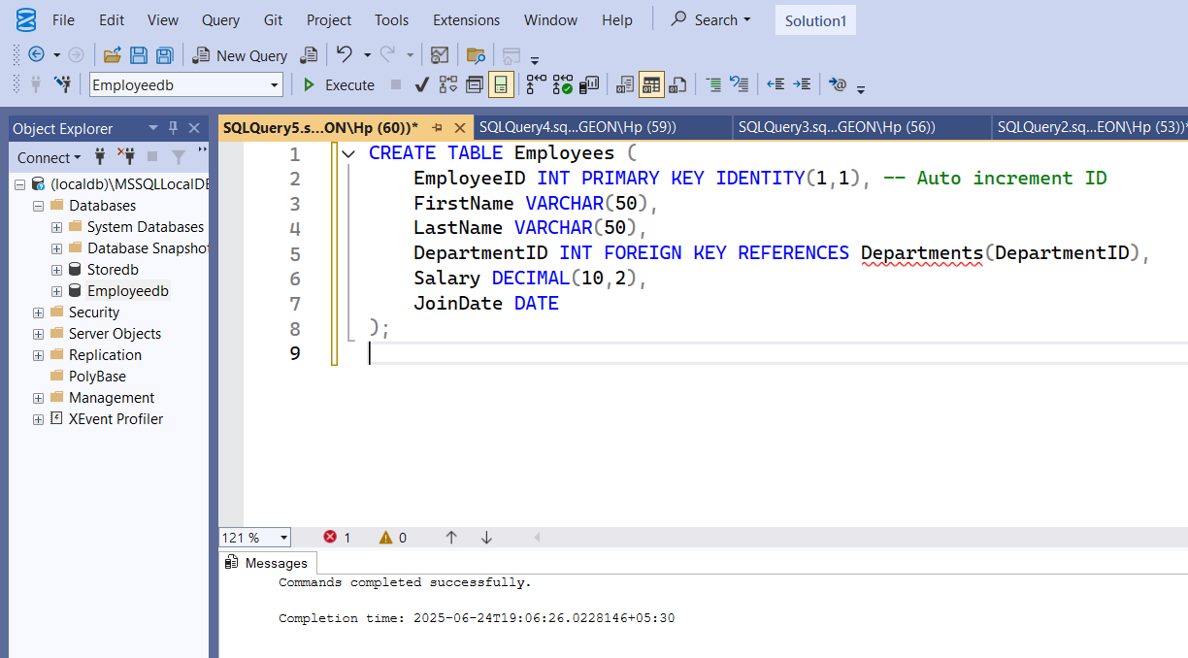

Step 3: Insert Sample Data into Departments and Employees table

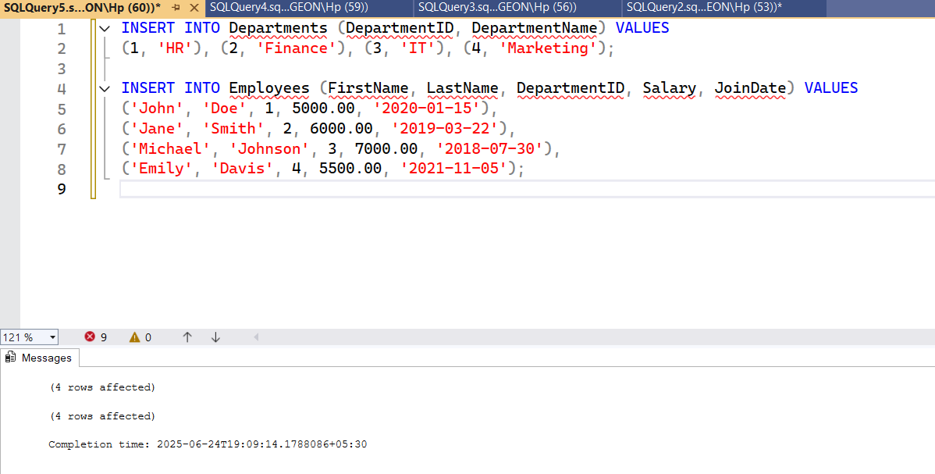

Step 4: Create sp_GetEmployeesByDepartment

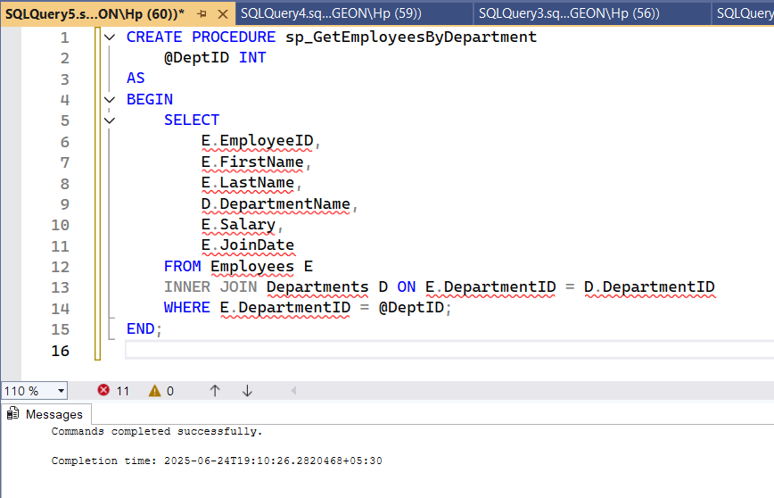

**OUTPUT:**

Returns a list of employees with their ID, name, department name, salary, and joining date.

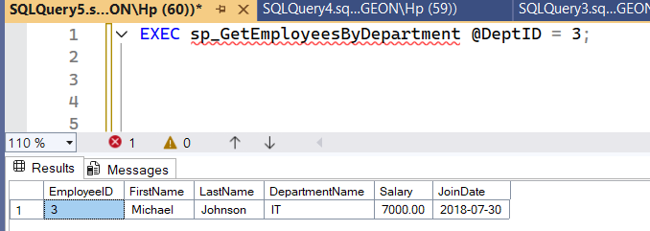

**Exercise 4: Execute a Stored Procedure**

**Goal:** Execute the stored procedure to retrieve employee details for a specific department.

**Steps**:

1. Write the SQL command to execute the stored procedure with a DeptID parameter.



2. Execute the command and review the results.

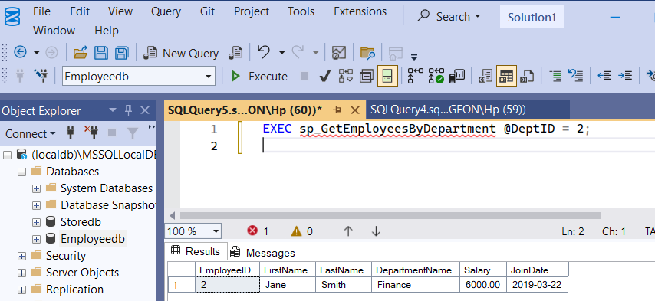

After executing the stored procedure sp_GetEmployeesByDepartment with @DeptID = 2, the results grid in SSMS displayed employee data for the Finance department. This validated the correct filtering of employee records by department ID.

**Exercise 5: Return Data from a Stored Procedure**

**Goal:**

Create a stored procedure that returns the total number of employees in a given department.

**STEPS:**

Step 1: Define the stored procedure with a parameter for DepartmentID

We need to accept a department ID to filter the count.

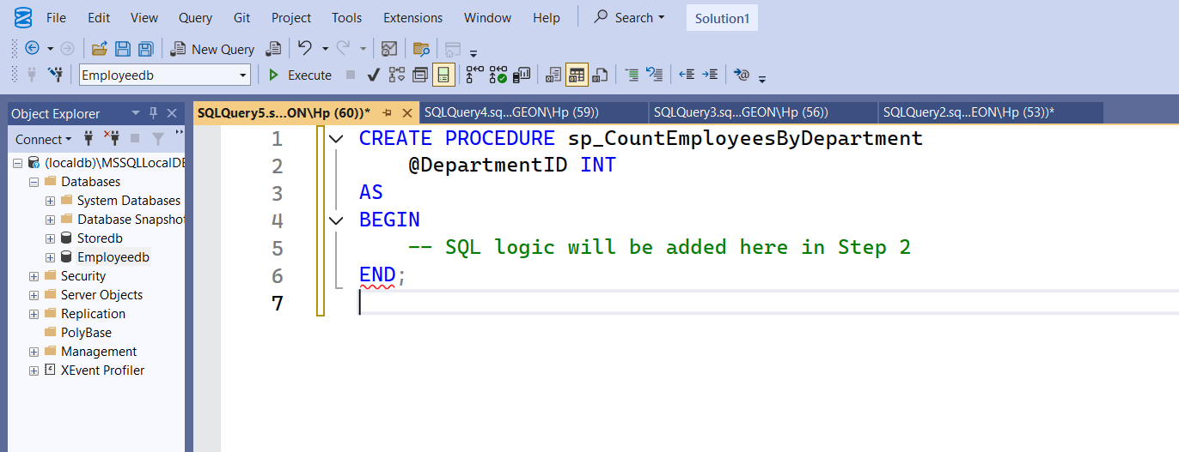

Step 2: Write the SQL query to count the number of employees in the specified department

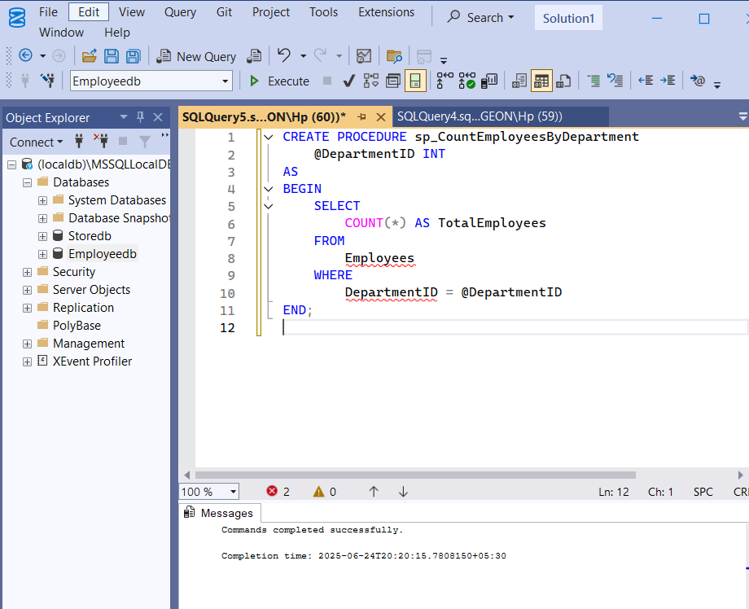

3. Save the stored procedure by executing the Stored procedure content.

It was saved by executing the complete procedure definition in SSMS

